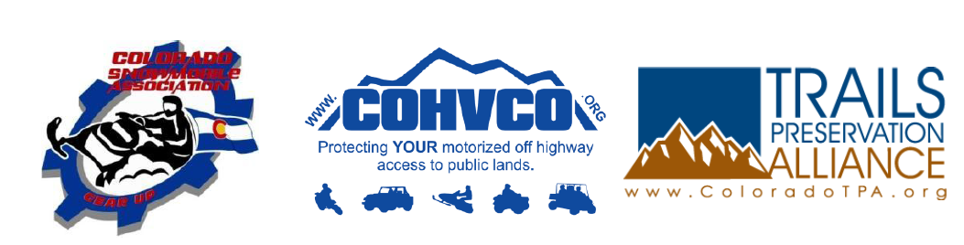
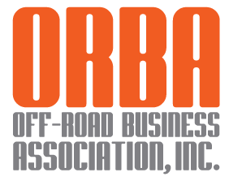

June 7, 2017

Congressman Doug LaMalfa
322 Cannon House Office Building
Washington, DC 20515

Re: HR 289 - Guide and Outfitters ("GO") Act

Dear Congressman LaMalfa:

Please accept this correspondence as the support and input of the Organizations identified above with regard to the Guide and Outfitters Act ("GO Act"). It has been the Organizations experience that too often event related permits are inconsistently administered between planning areas, administered slowly or in a manner that simply does not reflect the small nature of the event or are only provided at a cost that exceeds reasonable costs for the permit issuance. While the GO Act is a major step in resolving these issues, the Organizations would suggest that the scope of the GO Act be expanded to include permits that may be issued jointly between USFS or BLM and the Army Corp of Engineers, Bureau of Reclamation, Department of Defense and other Federal land management agencies. Many times these additional land managers are tangentially related to permits for events or other activities and limiting the scope of the streamlined permitting process to just BLM and USFS permits would not fully resolve our concerns around the current permitting process.

Prior to addressing our experiences with the challenges of obtaining consistent and timely permits for a wide range of events, we believe a brief summary of each Organization is needed. The Off-Road Business Association ("ORBA") is a national not-for-profit trade association of motorized off-road related businesses formed to promote and preserve off-road recreation in an environmentally responsible manner. The Colorado Off-Highway Vehicle Coalition ("COHVCO") is a grassroots advocacy organization the 150,000 registered OHV users in Colorado seeking to represent, assist, educate, and empower all OHV recreationists in the protection and promotion of off-highway motorized recreation throughout Colorado. COHVCO is an environmental organization that advocates and promotes the responsible use and conservation of our public lands and natural resources to preserve their aesthetic and recreational qualities for future generations.

The Trail Preservation Alliance ("TPA") is a 100 percent volunteer organization whose intention is to be a viable partner, working with the United States Forest Service (USFS) and the Bureau of Land Management (BLM) to preserve the sport of trail riding. The TPA acts as an advocate of the sport and takes the necessary action to insure that the USFS and BLM allocate to trail riding a fair and equitable percentage of access to public lands.
Colorado Snowmobile Association ("CSA") was founded in 1970 to unite winter motorized recreationists across the state to enjoy their passion. CSA advocates for the 30,000 registered snowmobiles in the State of Colorado. CSA has become the voice of organized snowmobiling seeking to advance, promote and preserve the sport of snowmobiling by working with Federal and state land management agencies and local, state and federal legislators.
While the primary mission of the Organizations most directly relates to motorized recreation, the overall scope of the Organizations often has a larger impact as motorized recreation and access can take many forms and involve many activities, including camping, hunting and fishing and other recreational activities where motorized access to public lands is critical but not the primary recreational activity sought. Under federal land management standards, when an area is open to motorized access it is rarely closed to any other activity. For purposes of this document, CSA, COHVCO and TPA are identified as "the Organizations". The Organizations are providing the following examples of why we support the streamlining of the permit process as it has been our experience that often the "why" behind the position of support for Legislation is as important as the support itself.
1. The scope of permit streamlining efforts should be expanded to allow for full inclusion of federal land managers involved in event permitting.

The Organizations are aware that often time’s permits are issued involving a wide range of smaller federal lands managers beyond just the US Forest Service and Bureau of Land Management. Often these smaller land management agencies provide a crucial, albeit smaller role, in an event occurring. Such a case would be when a permit for a 100 event route is issued and 95 miles of the route is on USFS or BLM lands but a critical 5 miles is needed to connect the loop for the event occurs on lands managed by another federal agency. The Organizations are active participants in the annual "King of the Hammers" race event in Southern California and are aware that the event occurs primarily on BLM lands but a small portion of the event route crosses the 29 Palms Marine Base. As a result permits for the King of the Hammers event must be provided by the Department of Defense in conjunction with the BLM. The Organizations would note that only partially streamlining the permit process with respect to land management agencies for these types of cross border events on federal lands would hinder the benefits of the GO Act. The limited streamlining of permitting may lead to a large amount of frustrations from permit applicants as what is a small portion of the lands necessary for the event to occur being the more difficult to obtain permits for the event on. The Organizations submit that avoiding this type of frustration should be a high priority for the GO Act as such frustration would clearly be an unintended consequence of the Legislation.

The Organizations are not directly familiar with the specific permitting process of these other land management agencies, but would become concerned if the GO Act would need extensive revision to encompass these management agencies. Streamlining of the permit process is somewhat time sensitive as well. The Organizations believe that a complete revision of the GO Act may not be necessary to embrace these smaller land management agencies as we believe providing the voluntary "opt in" to the streamlined permitting process on a case by case basis. This voluntary “opt in” type streamlining may allow for a streamlined permitting process without opening the entire permitting process for these agencies if there was significant conflict in these other agencies permitting process.

2. Small events are often prohibited under current permit requirements.
The Organizations vigorously support the GO Act streamlining of the permit process as the GO Act will provide significant benefit to those hosting smaller socially based not for profit type events. It has been the Organizations experience that too often small events, such as trail rides of a limited number of OHV's (sometimes groups as small as 5 vehicles) organized through a local club on designated routes or county roads crossing federal public lands are prohibited due to the fact that land managers believe a permit is required for the event. Often this position is taken based on the small fee collected in relation to the event in order to off-set direct costs of the event such as food provided on the event or facility rentals(such as town parks or similar facilities) where a social function such as a barbeque is provided after the event is concluded. Often these smaller types of events are great ways for new residents of a geographic area to connect with people that are familiar with the challenges and opportunities that the area provides and allow for these new residents to access these locally available and exceptional recreational opportunities in a safe and responsible manner.

The Organizations are aware that often far too much weight is placed on these small fees obtained to offset direct costs of the event. These fees were never intended to create a profit for the club that might be organizing the event but are merely put in place to supplement club dues that may not be of sufficient amount to cover the supplies that are being provided for the event. Often for events of this small size, the permit cost simply exceeds any costs that could reasonably be paid by an attendees and far exceeds any other costs incurred for such an event and as a result, the events simply don't occur. When the permit costs and efforts to obtain the permit are broken down to a per user cost, the cost is simply horribly out of reach for those that would like to attend the event. This is often highly frustrating to members of the public, who simply don't understand why a permit is even required for the event. The GO Act would be a significant step towards resolving these types of unnecessary challenges.

3. Timely permits for events often cannot be issued.

The Organizations are also aware of numerous situations where permits for events simply cannot be issued in a timely manner due to a wide range of issues surrounding the permit issuance. Frequently many small events are simply not thought of months or years in advance but are more of informal nature and may only be organized at a club meeting a month or two in advance and this type of event development is completely at odds with a permitting process that often requires at least an 18 month lead time for permit applications.

While these events may be less formal in nature, these events provide important recreational opportunities to those that are participating in the event. Often these small less formal events simply cannot be planned more than 18 months in advance and do not have the resources to undertake extensive review of possible impacts for what are existing routes and facilities. Often event coordinators simply don't pursue the event due to the barriers that are presented by the permitting process, which is unfortunate at best and a major barrier to access to public lands at worst. The streamlining of the permit process would allow permits to be issued in a timely manner and we believe the GO Act is a significant step in the right direction on this issue.

4. Streamlining of the permit process will improve the overall efficiency of land managers.

Streamlining of the permit process for small events under the GO Act would also allow for the more efficient utilization of what are becoming more and more limited agency resources every year. The streamlining of event permits would reduce the administrative burdens placed on land managers to comply with permitting requirements that are overly broad or designed to address events that are much larger than the group that might be applying for a small event permit. The Organizations believe that allowing the land managers to properly address permitting in relation to the size of the event will allow agency time and other resources to be directed toward actively addressing significant issues or challenges in a planning area which would increase efficiency and provide for a better recreational experience to all users of public lands. Both of these are important benefits given the ever shrinking budgets for federal land managers.

4. Fees charged for permits are often unrelated to actual permitting costs.

The Organizations are also aware of numerous events where the permitting costs simply exceed any reasonable costs for the administration of the permit, which creates unnecessary conflict between users and land managers. In certain instances, these unduly large permit application costs preclude the event from ever happening and in other instances these large costs are simply passed through to event participants, and as a result events on public lands can cost more than if the event had occurred on adjacent private lands. Neither of these situations is acceptable to the Organizations and in certain circumstances these large fees have created the possible public perception that certain groups are charged certain fees and other groups with similar events are charged a lesser fee and that these decisions are made in a somewhat arbitrary manner but the deciding official. Avoiding these types of issues should be of paramount importance in the permitting process.

The Organizations submit that often the public perception of these large event permit costs are that the permit revenue is being used a profit center for that office or land management agency to offset overhead costs to the office for operations that are unrelated to the permitted event. While the Organizations often partner to assist in offsetting operational costs, the Organizations also firmly believe that permitting of activities should not be a profit center for land managers, as this is simply a violation of the trust placed in these managers by the public. Avoiding even a perception of such a situation should be a major priority in the streamlining of the permit process and we believe that the GO Act would be a major step forward in avoiding a possible appearance of impropriety in the permitting process.

5. Existing partnerships would be repaired with a streamlined permitting process.

The Organizations believe the streamlining of the permit process under the GO Act would help repair partnerships between federal land managers and local Organizations, as often the same local club that is not allowed to undertake an event due to permitting issues is a major source of both volunteer labor and partner funding for the land management agency. Forming these types of partnerships can be difficult and stressful for volunteers and the failure to obtain permits in a timely and cost effective manner can simply provide unnecessary stress on this relationship. The Organizations are aware of federal land managers requiring a permit for a club event involving less than 10 street legal motorcycles using a route entirely on county roads due to the fact that the riders might stop at a parking area adjacent to the county road to use a bathroom facility on BLM lands. This request created amazing stress on the partnership between the club and the land managers as the club was the Organization spearheaded efforts in obtained all funding for the construction of the parking lot and restroom facilities through a state OHV grant several years prior. Again the Organizations believe that the streamlined permitting process under the GO Act would be a significant step towards resolving these types of challenges.
6. Conclusion.

It has been the Organizations experience that too often event related permits are frequently inconsistently administered, administered slowly or in a manner that simply does not reflect the small nature of the event or are only provided at a cost that exceeds reasonable costs for the permit issuance. The Organizations submit that the GO Act would be a major step forward in resolving many of the challenges that have been encountered with the permitting of events with both the Organizations and our member partners.

While the GO Act is a major step in resolving these issues, the Organizations would suggest that the scope of the GO act be expanded to include permits that may be issued jointly between USFS or BLM and the Army Corp of Engineers, Bureau of Reclamation, Department of Defense and other Federal land management agencies. Many times these additional land managers are tangentially related to permits for events or other activities and limiting the scope of the streamlined permitting process to just BLM and USFS permits would not fully resolve our concerns around the current permitting process.

The Organizations look forward to participating in further meetings on this issue and welcome the discussion as it moves forward.

Respectfully Submitted,
Scott Jones, Esq.  CSA President  TPA & COHVCO Authorized Representative | 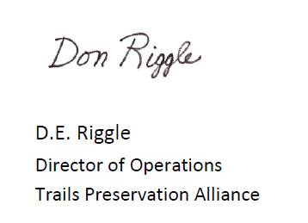

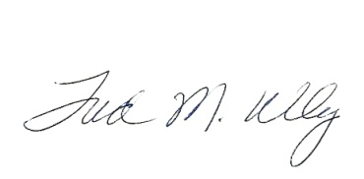
Fred Wiley
President/CEO

